Software Requirements Specification

Version 1.0

Employee Travel Requisition System

Chapter 1

INTRODUCTION

1.1. Purpose
The purpose of this document is to present a detailed description of the Employee Travel Management & Reimbursement System. It will explain the purpose and features of the system, the interfaces of the system, what the system will do and the constraints under which it must operate.

1.2. Scope of Project
The main objective of the project is to automate the existing travel system. It will help the employee to manage the travel plans. Our project aims at Business process automation, ie. We have tried to computerize various processes of travel.

1.3. Existing System
In the present system the employee has to go and tell the travel agent regarding the business trip. It is a tedious work for employee to take approval from the project manager and then taking the approved request to the travel agent to book the tickets. It may happen that the project manager is unavailable to give the approval for the trip which may have come spontaneously to the employee. The travel agent has to maintain the paperwork of the documents and also have to maintain the travel expenses. The travel agent has to get approval from the project manager regarding the trip in case the cost exceeds the permitted slab to the employee.

1.4. Proposed System
A Web based approach towards maintaining travel request from employee in a centralized manner and ultimately reducing the paperwork involved in each application and automating the entire process to make the application process faster and easier. The system will allow one to easily access the relevant information and make necessary travel arrangements from one single interface.

Chapter 2
Design

2.1 Functional Requirements

- Employee
- Employee will make a request for his travel booking and request will be forwarded to respective Project Manager.
- The Employee can view their request status.
- The Employee can view the ticket, accommodation details and forex given (if any).

- Project Manager
- The project manager can authorize the employee for business travel. He/she can also raise request for travel.
- He can approve/reject if the travel plans exceeds the given slab to the employee.

- Travel Agent
- On receiving the request of the employee, depending upon the slab of the employee he will approve/disapprove the request of the employee and it will pass the status to Project Manager & Booking will be done accordingly.
- If the slab is not matching for the employee, he will inform the Project Manager and request will get forwarded to Director and action will be taken accordingly.
- He can book the ticket and accommodation for the employee.

2.2 Non-Functional Requirement
Software & Hardware Requirement

Development Technologies | Spring Boot, Maven(Build Tool)
Development Tools | Eclipse IDE , JDK 1.8
Application Server | Apache Tomcat
Database | Oracle
Operating System | Windows 7 or Later
Web Browser | Google Chrome or Others
Hardware | 1. 4gb Ram  2. 500GB HDD

2.3 Activity Diagram
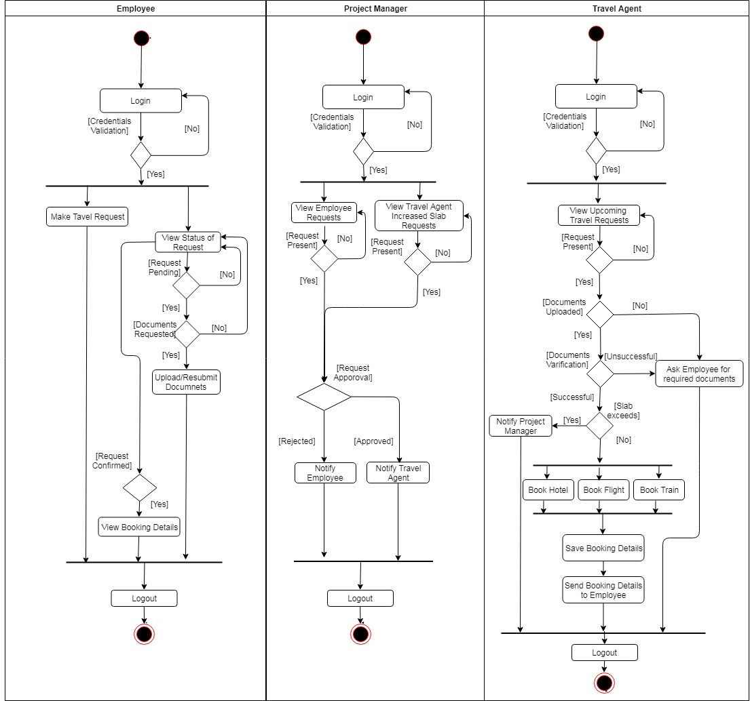

2.4 Sequence Diagram

Scenario 1:
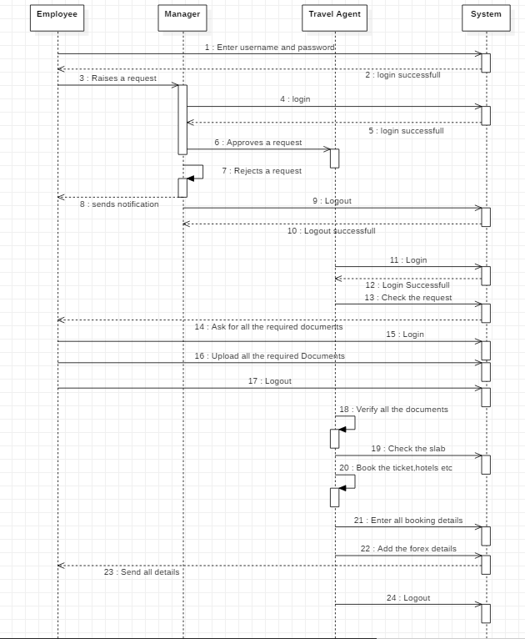

Scenario 2:
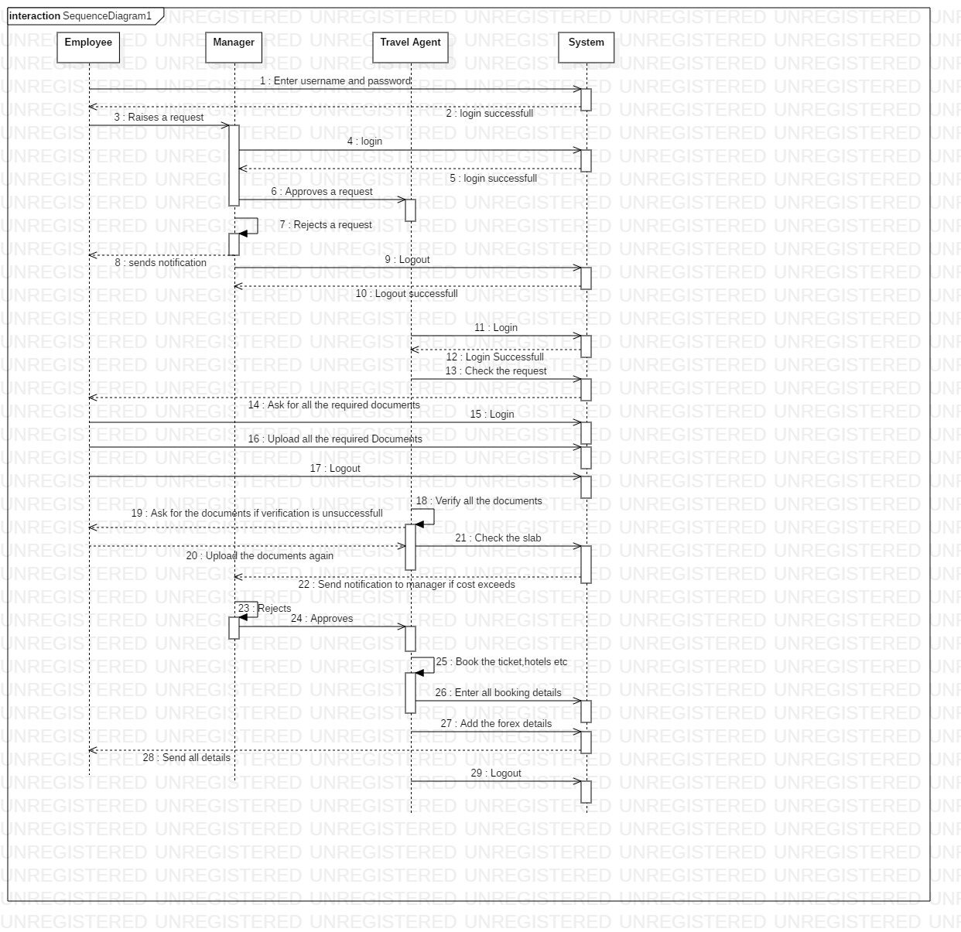

2.5 Revision History

Name | Date | Reason For Changes | Version
Initial | 23/08/2018 | First Version | 1.0

Table of Contents
- Actors
- Use Case List

1.Actors

- Employee- The employee can raise a request for business travel trip.

- Project Manager- The project manager can authorize the employee for business travel. He/she can also raise request for travel.

- Travel Desk- He/she can view request, check whether the request falls in the criteria and book the travel tickets, hotel accommodation, allots travel expenses and send travel details to the employee.

Use Case Diagram
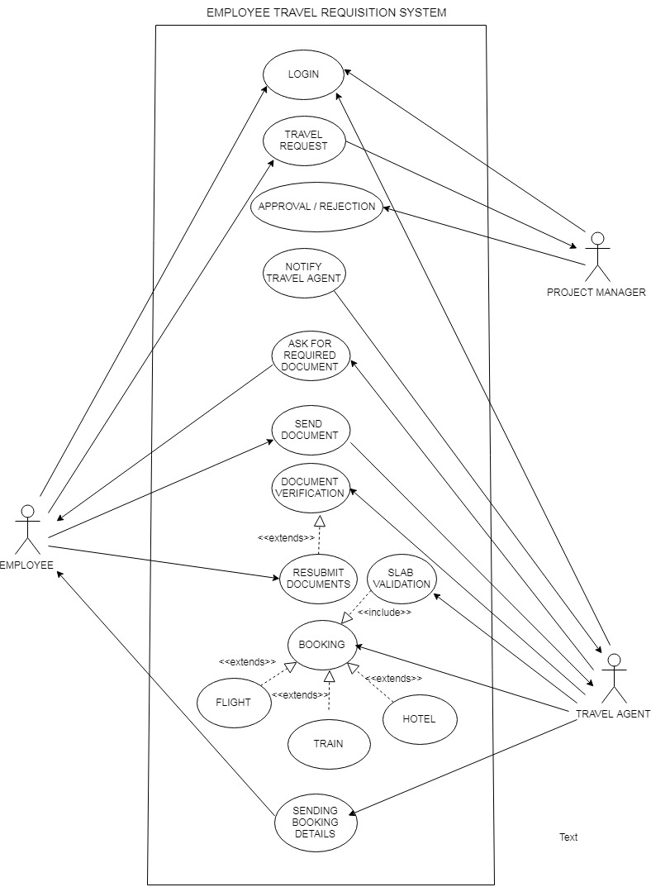
2.6 Use Case List
2.6.1 Employee:

Use Case ID: | UCE-1
Use Case Name: | Login to the system
Created By: |  | Last Updated By:
Date Created: |  | Date Last Updated:

Actor: | Employee
Description: | Employee will be prompted to login with their employee id and password.
Preconditions: | 1. Employee has an account  2. Employee is trying to log in with their account credentials.
Postconditions: | 1.The Employee is logged in to the system  2. The employee can access to the functions of the system
Priority: | High
Frequency of Use: | Every time the Employee wants to access the system
Normal Course of Events: | 1.1 The system prompts the employee for their account credentials  1.2 The employee enters their employee id and password  1.3 The system authenticates the employee
Alternative Courses: | Invalid account credentials
Exceptions: | Incorrect credentials
Includes: | None
Special Requirements: | Access security
Assumptions: | The employee wants to use the system

Use Case ID: | UCE-2
Use Case Name: | Logout to the system
Created By: |  | Last Updated By:
Date Created: |  | Date Last Updated:

Actor: | Employee
Description: | Employee clicks on “logout” and their session terminated.
Preconditions: | Employee is logged in.
Postconditions: | The Employee is logged out.
Priority: | Medium
Frequency of Use: | Every time the employee gets logged in employee has to get logged out.
Normal Course of Events: | 1.1 The Employee clicks on logout button.  1.2 The system invalidate the cookie/session of that employee  1.3 The system redirects to the default logout page.
Alternative Courses: | None

Use Case ID: | UCE-3
Use Case Name: | Travel Request
Created By: |  | Last Updated By:
Date Created: |  | Date Last Updated:

Actor: | Employee
Description: | Employee clicks on Travel Request and can raise a travel request
Preconditions: | 1.Employee is logged in.  2.Employee should be aware about the travel plan/details.
Postconditions: | 1.The Employee must send the request to the authority.  2.The employee has to wait for the approval from the authority.
Priority: | High
Frequency of Use: | Every time the employee wants to travel for business trip
Normal Course of Events: | - Employee fills the details in the travel form.  1.2 The employee sends the request to higher authority.
Alternative Courses: | Required details not filled.
Exceptions: | Insufficient data filled
Includes: | UCE-8(Approval request by project manager)
Assumptions: | Unless it is not a business purpose one cannot raise a travel request.

Use Case ID: | UCE-4
Use Case Name: | Required Documents
Created By: |  | Last Updated By:
Date Created: |  | Date Last Updated:

Actor: | Employee
Description: | Employee sends the required documents for travel.
Preconditions: | 1. Employee is logged in.  2. Employee should have original documents in pdf format.
Postconditions: | 1.The employee must upload the required documents
Priority: | High
Frequency of Use: | When the travel agent requests to upload the details
Normal Course of Events: | 1.1 Travel Desk sends the request for documents  1.2 The employee uploads the documents in the pdf format.  1.3 The documents are sent to the travel agent.
Alternative Courses: | Uploading document failed.
Exceptions: | Documents should be in PDF format
Assumptions: | The travel desk has requested for the documents

Use Case ID: | UCE-5
Use Case Name: | Resubmit documents
Created By: |  | Last Updated By:
Date Created: |  | Date Last Updated:

Actor: | Employee
Description: | Employee will Upload the Documents Requested by Travel Agent.
Preconditions: | Employee will update the documents requested by travel agent.
Postconditions: | Travel Agent will verify the documents.
Priority: | Medium
Frequency of Use: | Whenever there is Request for update of documents by Travel agent.
Normal Course of Events: | 1.1.Travel Agent will request employee for specific documents  1.2. Employee will get request for re-upload of documents by Travel Agent.  1.3. Employee will upload the Documents.  1.4 Travel Agent can then view the documents.
Includes: | UCE-13(Document Verification)

2.6.2 Project Manager:
Use Case ID: | UCE-6
Use Case Name: | Login to the system
Created By: |  | Last Updated By:
Date Created: |  | Date Last Updated:

Actor: | Project Manager
Description: | Project Manager will be prompted to login with their employee id and password.
Preconditions: | 1. Project Manager has an account  2. Project Manager is trying to log in with their account credentials.
Postconditions: | 1.The Project Manager is logged in to the system  2. The Project Manager can access to the functions of the system
Priority: | High
Frequency of Use: | Every time the Project Manager wants to access the system
Normal Course of Events: | 1.1 The system prompts the Project Manager for their account credentials  1.2 The Project Manager enters their employee id and password  1.3 The system authenticates the Project Manager
Alternative Courses: | Invalid account credentials
Exceptions: | Incorrect credentials
Includes: | None
Special Requirements: | Access security
Assumptions: | The Project Manager wants to use the system

Use Case ID: | UCE-7
Use Case Name: | Logout to the system
Created By: |  | Last Updated By:
Date Created: |  | Date Last Updated:

Actor: | Project Manager
Description: | Project Manager clicks on “logout” and their session terminated.
Preconditions: | Project Manager is logged in.
Postconditions: | The Project Manager is logged out.
Priority: | Medium
Frequency of Use: | Every time the Project Manager gets logged in Project Manager has to get logged out.
Normal Course of Events: | 1.1 Project Manager clicks on logout button.  1.2 The system logs the PM out and invalidates the cookie/session  1.3 The system redirects to the default logout page.

Use Case ID: | UCE-8
Use Case Name: | Approval or Rejection to the employee request
Created By: |  | Last Updated By:
Date Created: |  | Date Last Updated:

Actor: | Project Manager
Description: | Project Manager will approve or reject the travel request  (if approved he will notify to the Travel Agent).
Preconditions: | List of request should be displayed.
Postconditions: | 1. The Project Manager can approve or reject the request of Employee and Travel Agent(approve).
Priority: | High
Frequency of Use: | Only when the request is raised by Employee or Travel Agent
Normal Course of Events: | 1.1 The Project Manager view the Request.  1.2 Project Manager will accept or reject the request of employee (If accepted then he will notify to the Travel Agent )

Use Case ID: | UCE-9
Use Case Name: | Approval/Rejection of travel agent request
Created By: |  | Last Updated By:
Date Created: |  | Date Last Updated:

Actor: | Project manager
Description: | If employee slab is exceeds travel agent with notify project manager and as per project budget Project manager will approve/reject the request.
Preconditions: | Travel Agent should request to Project manager about exceed slab.
Postconditions: | Project manager either approve/reject the request.
Priority: | Medium
Frequency of Use: | When there are project interruptions like meeting is postponed, etc.
Normal Course of Events: | - Project manager will able to see all sent request from travel agent.  - Project manager will approve/reject the request.
Assumptions: | The trip has been cancelled or postponed.

2.6.3 Travel Agent:
Use Case ID: | UCE-10
Use Case Name: | Login to the system
Created By: |  | Last Updated By:
Date Created: |  | Date Last Updated:

Actor: | Travel Agent
Description: | Travel Agent will be prompted to login with their user id and password.
Preconditions: | 1. Travel Agent has an account  2. Travel Agent is trying to log in with their account credentials.
Postconditions: | 1.The Travel Agent is logged in to the system  2. The Travel Agent can access to the functions of the system
Priority: | High
Frequency of Use: | Every time the Travel Agent wants to access the system
Normal Course of Events: | 1.1 The system prompts the Travel Agent for their account credentials  1.2 The Travel Agent enters their user id and password  1.3 The system authenticates the Travel agent.
Alternative Courses: | Invalid account credentials
Exceptions: | Incorrect credentials
Includes: | None
Special Requirements: | Access security
Assumptions: | The Travel agent wants to use the system

Use Case ID: | UCE-11
Use Case Name: | Logout to the system
Created By: |  | Last Updated By:
Date Created: |  | Date Last Updated:

Actor: | Travel Agent
Description: | Travel Agent clicks on “logout” and their session terminated.
Preconditions: | Travel Agent is logged in.
Postconditions: | The Travel Agent is logged out.
Priority: | High
Frequency of Use: | Every time the Travel Agent gets logged in Travel Agent has to get logged out.
Normal Course of Events: | 1.1 The Travel Agent clicks on logout button.  1.2 The system logs the Travel agent out and invalidates the cookie/session  1.3 The system redirects to the default logout page.

Use Case ID: | UCE-12
Use Case Name: | Document Requirement Request
Created By: |  | Last Updated By:
Date Created: |  | Date Last Updated:

Actor: | Travel Agent
Description: | Travel Agent will send the request to the employee for sending required Documents.
Preconditions: | Travel Agent can see the request approved by project manager
Postconditions: | Travel Agent will Verify Documents.
Priority: | High
Frequency of Use: | Whenever PM approves the request.
Normal Course of Events: | 1.1 Travel Agent can view the request which are approved by pm.  1.2 Travel Agent sends request for required documents to Employee.
Alternative Courses: | UCE-5(Approve/reject the request raised by travel agent)
Exceptions: | Slab exceeds
Includes: | UCE-12(Booking)

Use Case ID: | UCE-13
Use Case Name: | Document Verification
Created By: |  | Last Updated By:
Date Created: |  | Date Last Updated:

Actor: | Travel Agent
Description: | Travel Agent will verify the document of Employee as per his Requirement.
Preconditions: | Travel Agent can see all the document Uploaded by the Employee
Postconditions: | Travel Agent will Book the Tickets.
Priority: | Medium
Frequency of Use: | Whenever there is Travel Request and Documents are Uploaded by the Employee.
Normal Course of Events: | 1.1 Travel Agent can view the documents which are uploaded by the Employee.  1.2 Travel Agent verify the documents.
Alternative Courses: | In Case Invalid Documents Travel Agent can Requests For Document
Exceptions: | Invalid Documents.

Use Case ID: | UCE-14
Use Case Name: | Booking
Created By: |  | Last Updated By:
Date Created: |  | Date Last Updated:

Actor: | Travel Agent
Description: | Travel Agent will book the tickets and hotels.
Preconditions: | Verification of documents must be completed.
Postconditions: | Travel Agent will book the hotels,travelling tickets according to particular slab provided by Project Manager for the employee.
Priority: | Medium
Frequency of Use: | When employee sends the documents for booking.
Normal Course of Events: | 1.1 Travel Agent can see the document list provided by employee.  1.2 Travel Agent will book the tickets in a slab which are provided by Project manager.
Alternative Courses:
Exceptions:
Includes: | UCE-15(Sending booking information)

Use Case ID: | UCE-15
Use Case Name: | Sending booking information
Created By: |  | Last Updated By:
Date Created: |  | Date Last Updated:

Actor: | Travel Agent
Description: | Travel Agent will send the booking information to the employee
Preconditions: | Travel Agent has booked the Tickets.
Postconditions: | 1. Travel Agent will send the booking information ,and confirmed hotel details to the employee.  2. Travel Agent will maintain booking information
Priority: | Medium
Frequency of Use: | Notify Employee regarding booking.
Normal Course of Events: | 1.1 Travel Agent sends the booking of Travelling and accommodation to employee.

